Assignment -1

# Objective:

To build a simple virtual reality world in Unity, you'll need to include:

* A flat surface (ground plane)
* A sky to surround your world (skybox)
* Objects like trees, buildings, or rocks
* Lighting to make things visible
* The ability to interact with objects using virtual hands

This will allow players to explore and manipulate the virtual environment.

# Guidelines:

* **Complete as much as you can:** Do your best to finish all the tasks.
* **Tasks have points:** Each task is worth a certain number of points.
* **Share your project:** Upload your final project to GitHub.
* **Document your work:** Create a document with screenshots and explanations for each task.
* **Record a demo:** Make a video showing your project in action.
* **Change the game code:** Modify the provided C# scripts to customize the game's behavior.

**Task 1:** Set Up Your Unity Project & Configure the VR Environment [5 marks]

# Create a New Unity Project

1. Start Unity Hub and select "Create a new project."

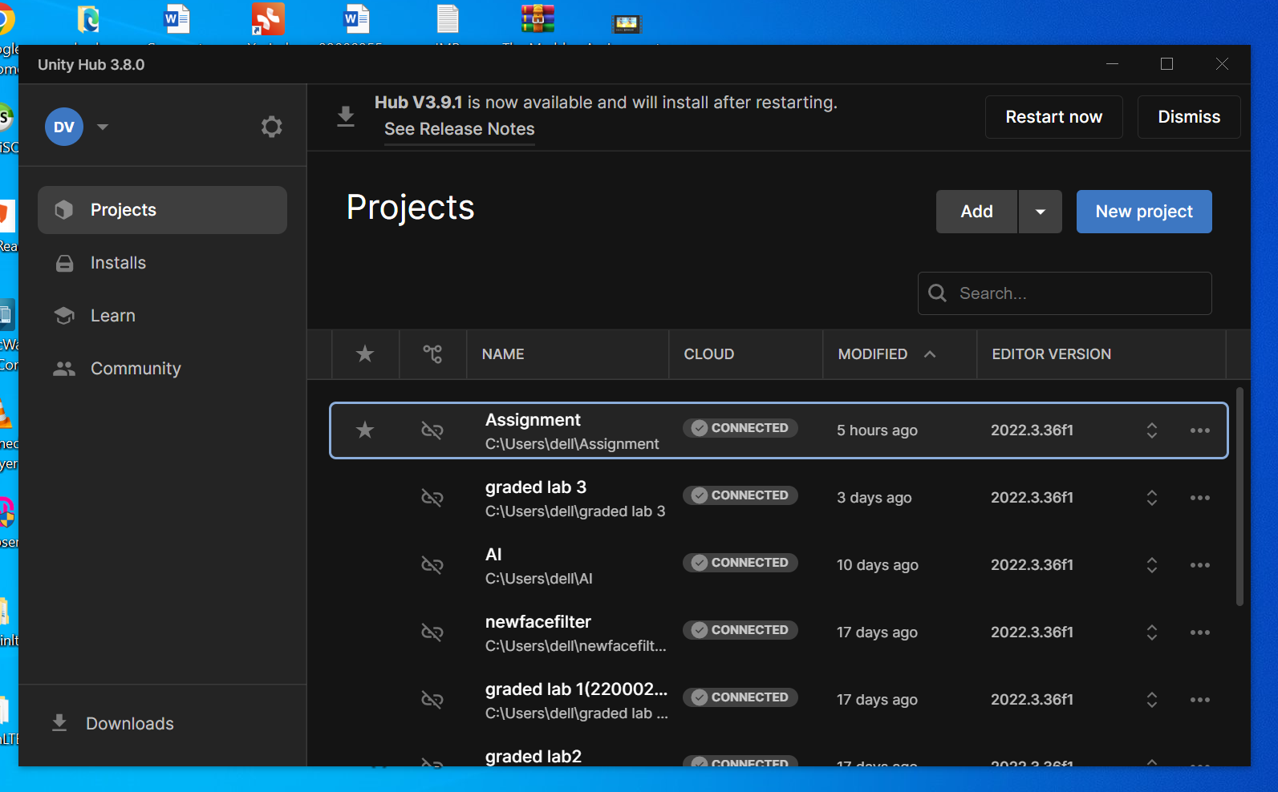

1. Choose a template or select “3D Build in Render Pipeline” to start with a basic 3D project.

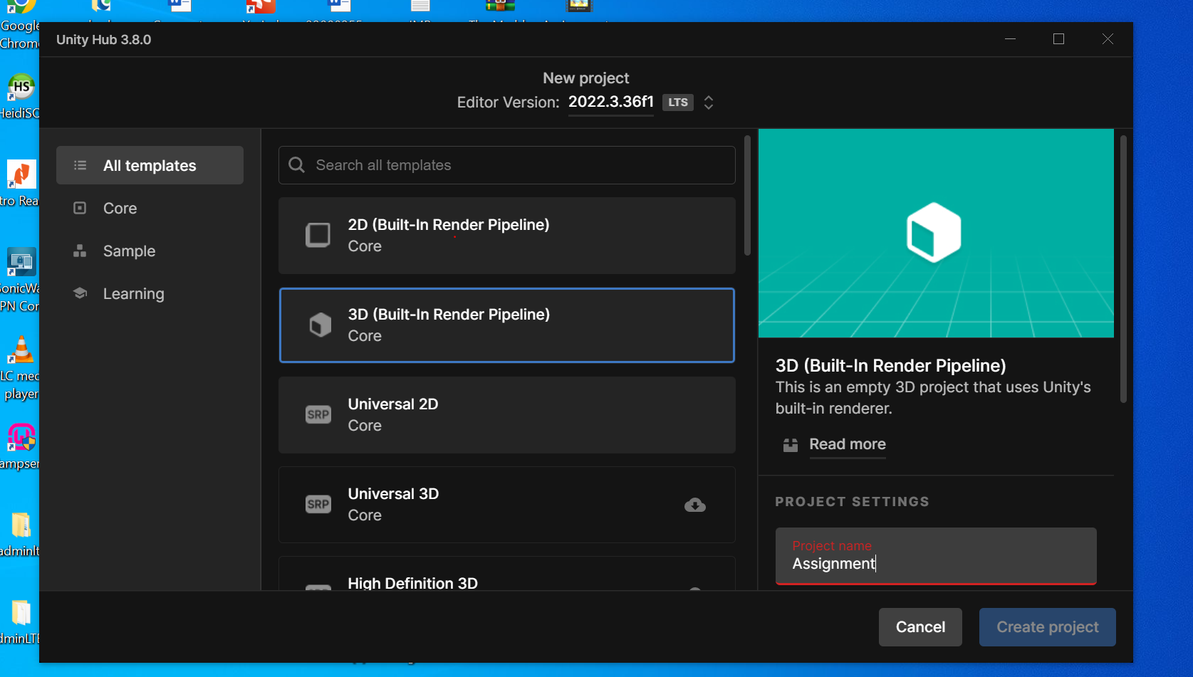

1. Set the project name and location, then click “Create Project.”

# Configure the VR Environment

1. In the Unity Editor, go to “Window” > “Package Manager.”

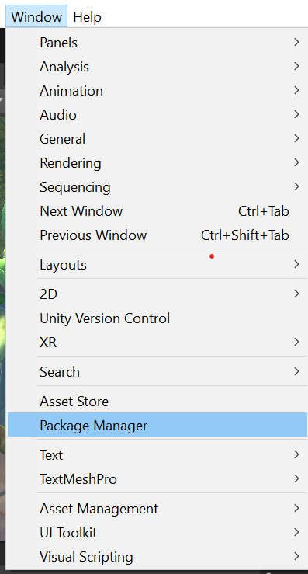

1. **Find the package manager:** Go to the "Packages" section in Unity.
2. **Install XR Plugin Management:** Search for and install this plugin.
3. **Install Oculus XR Plugin:** Follow the same steps as before to install this plugin.

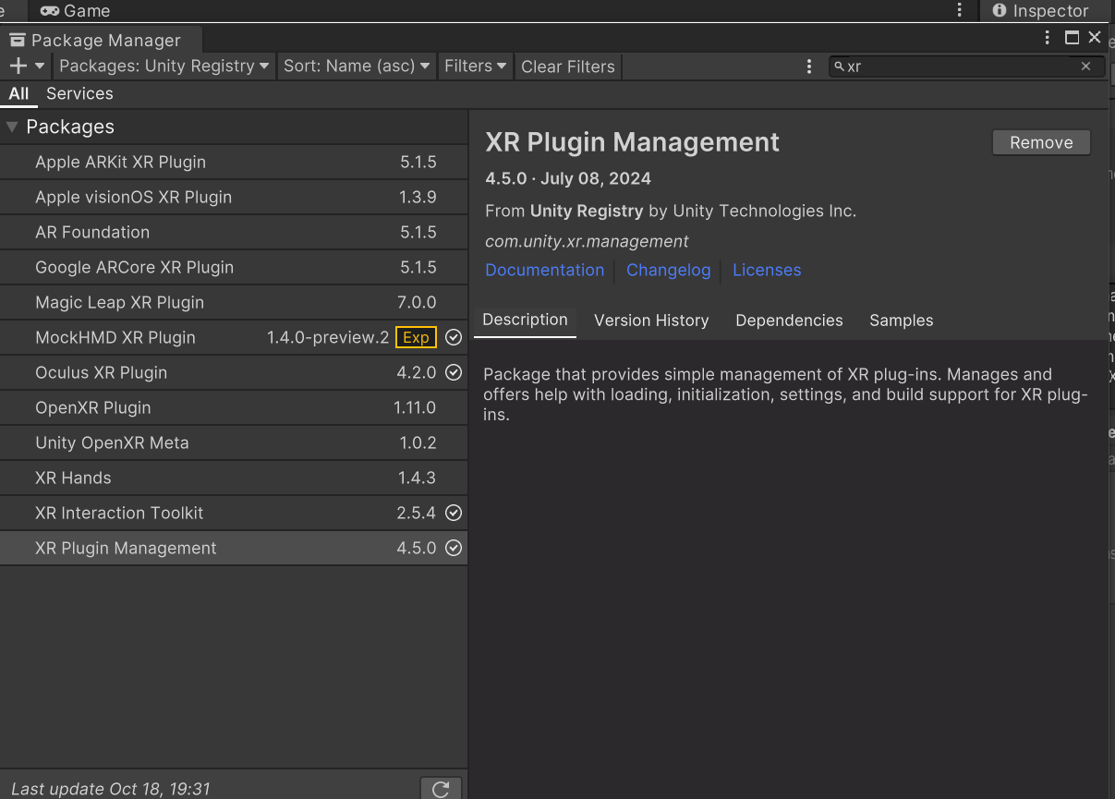

**Configure XR Settings**

1. Navigate to “Edit” > “Project Settings” > “XR Plugin Management.”

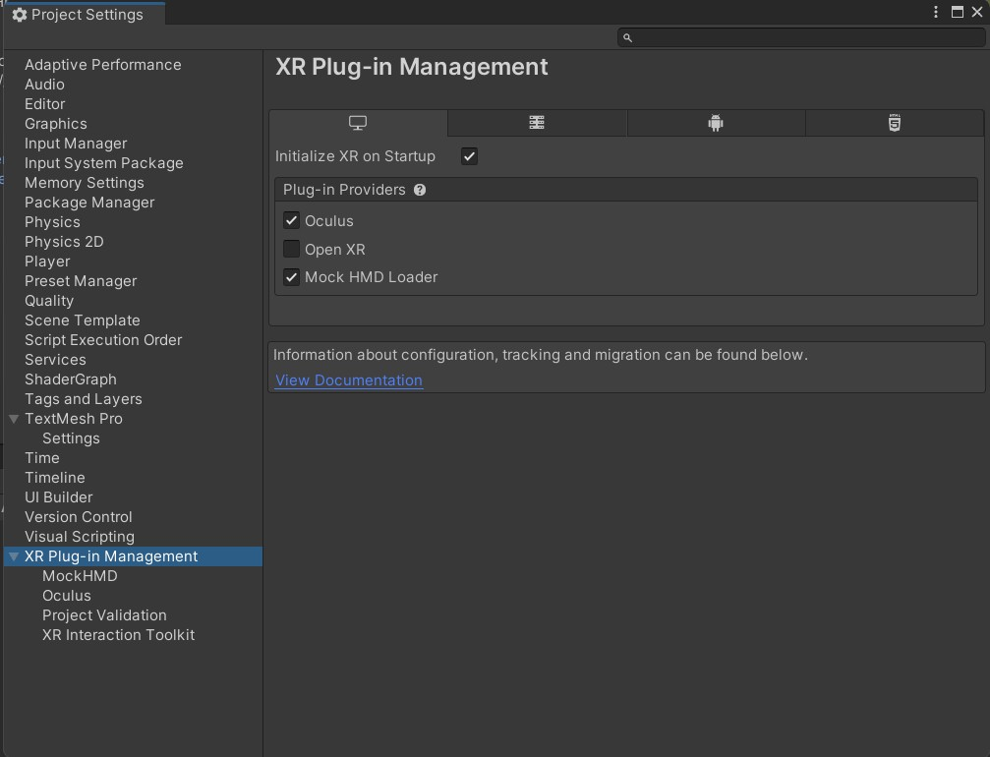

1. **Select Oculus and Mock HMD Loader:** Ensure these options are chosen, and any other VR platforms are not.
2. **Set up Android platform:** Choose the same settings for Android and enable "Initialize XR on Startup”.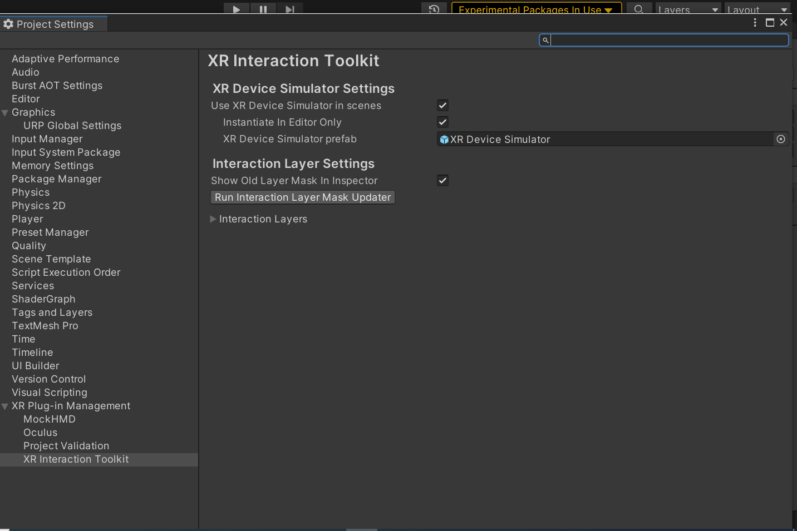

**Task 2:** Create the Ground Plane [5 marks]

* **Increase the ground size:** Make the ground area larger so you can move around more freely.
* **Use a Terrain object:** You can use this type of object to create a more complex and varied ground surface.

# Took the Asset for this task from Asset Store: -

* <https://assetstore.unity.com/publishers/4162>
* <https://assetstore.unity.com/publishers/5213>
* <https://assetstore.unity.com/publishers/6452>

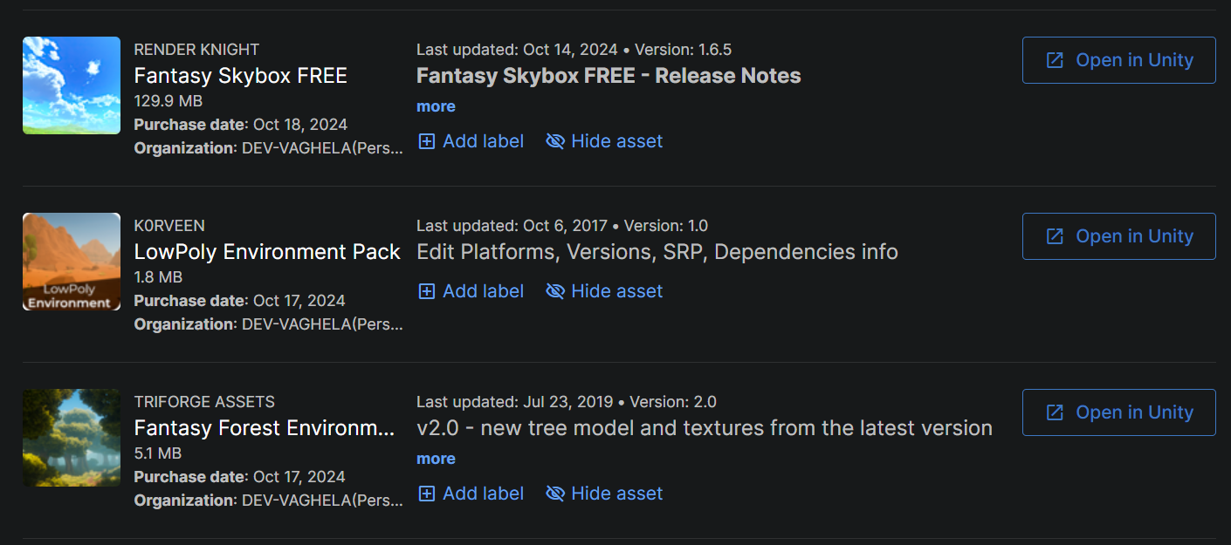

and loaded it in assignment Project

**Task 3:** Add a Skybox [5 marks]

* **Use ready-made sky settings:** You can use pre-designed sky settings to quickly add a sky to your scene.
* **Make the sky more realistic:** Try to create a sky that looks more detailed and interesting.

1. Find or Create a Skybox
   * **Get a skybox:** You can download a skybox from the Unity Asset Store or use one that's already in Unity.
   * **Make your own:** If you want a sky that's different from the others, you can create it using your own images.

**2.Set the Skybox:**

* Open the "Lighting" window by going to **Window > Rendering > Lighting**.
* In the opened window, look for the **Environment** tab.
* You'll see a section labeled "Skybox Material." Click the small circle next to it.
* A list of available skybox materials will appear. Choose the one you want to use for your scene.

**Task 4:** Add Environment Objects [15 marks]

* + - You can use Assets to create an engaging Environment
    - Create a grabbable objects spawning at random locations



**Task 6**: Configure Lighting and Shadows [5 marks]

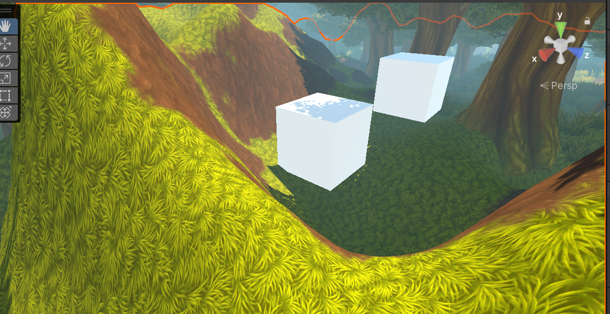

**1. Adjust the main light:**

* Use a **Directional Light** for your main light source, like the sun.
* **Change the brightness** using the "Intensity" slider.
* **Set the color** to create a specific mood (e.g., warm for sunset, cool for night).
* **Rotate the light** to control where shadows fall.

**2. Turn on shadows:**

* **Select the Directional Light** and make sure "Cast Shadows" is checked.
* **Choose shadow type:** Decide between **Soft Shadows** (blurry and realistic) or **Hard Shadows** (sharp edges).
* **Consider your scene:** Soft shadows are good for natural lighting, while hard shadows create a more defined look.

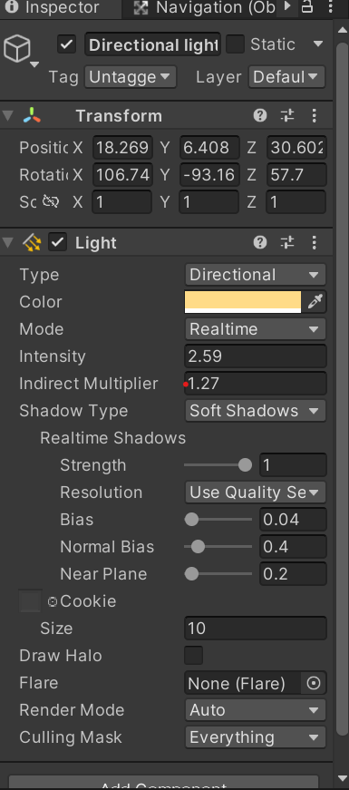

**Task 7:** Add Audio [5 marks]

# Import Your Audio Files

* **Add your audio file:** Drag and drop your audio file (like an MP3 or WAV) directly into the "Assets" folder in Unity. You can also use the "Assets > Import New Asset" option to select it

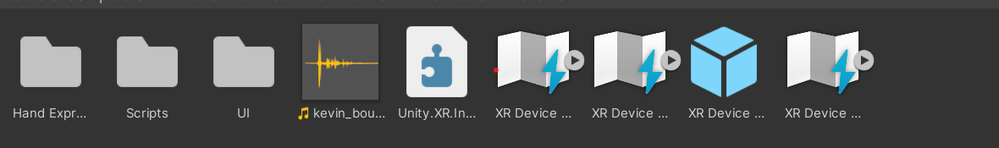

# Add an Audio Source:

* + **Attach an Audio Source:** The Audio Source component plays sounds. Add it to an object in your scene where you want the sound to originate (e.g., camera, character, object).
  + **Select the GameObject:** Choose the object where the sound will come from.
  + **Add the Audio Source:** Go to **Component > Audio > Audio Source**.
  + **Link the audio file:** In the Inspector, find the "Audio Source" component and drag your imported audio file into the "Audio Clip" field..

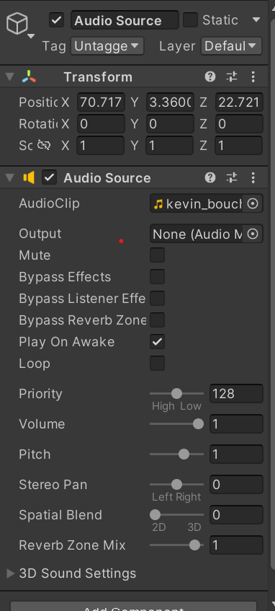

**Task 8:** Implement Basic VR Interaction [25 marks]

* + - Create a Grabbable Object
    - 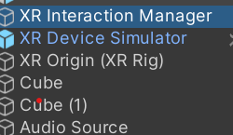
    - Add Grabbable and Grabber Components

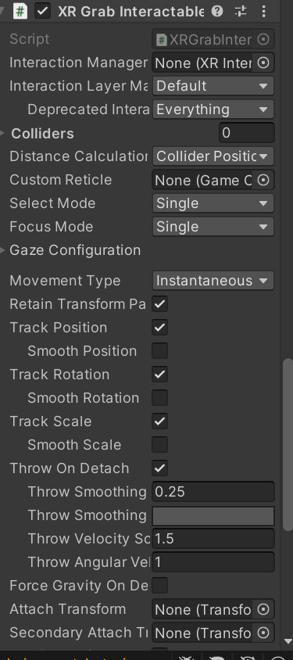

**Task 9:** Write the VR Interaction Script [25 marks]

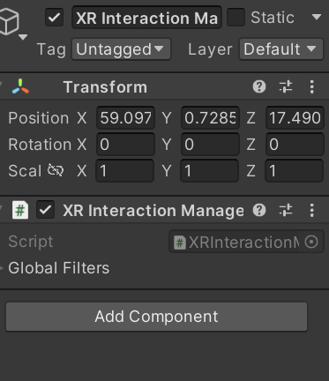

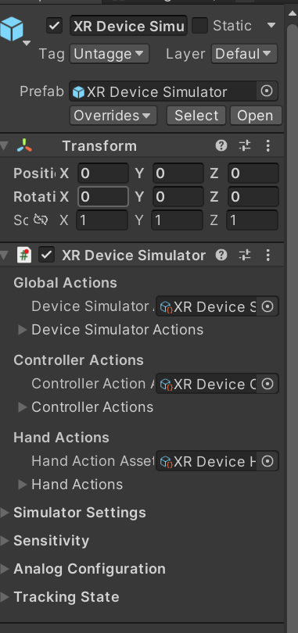

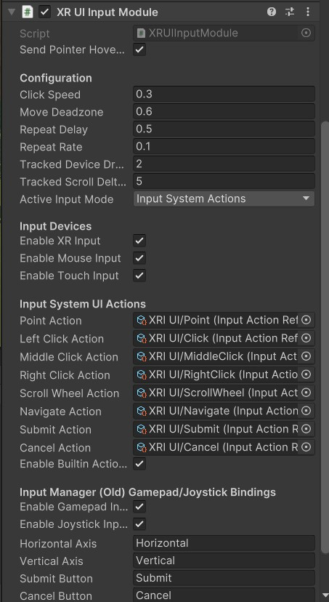

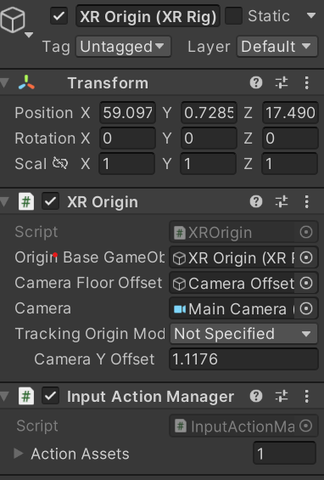

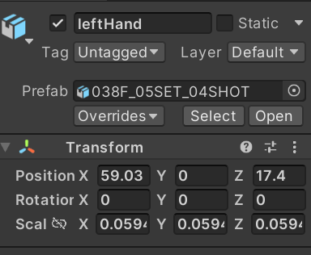

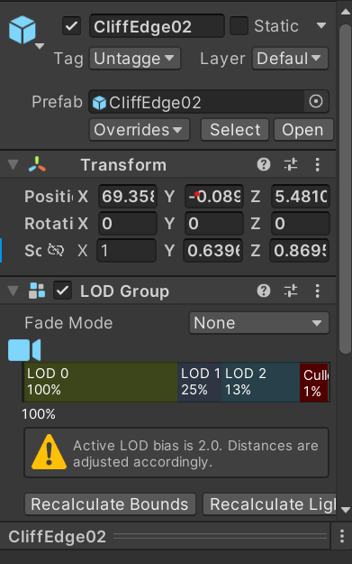

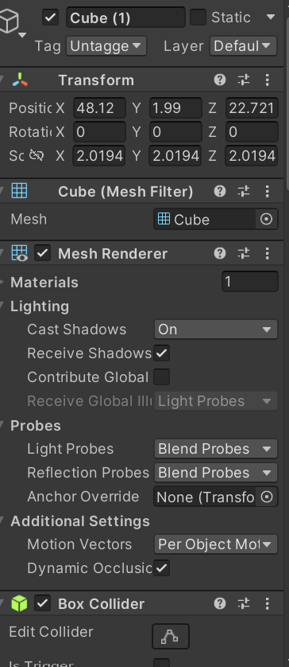

**Task 10:** Demo application [5 marks]

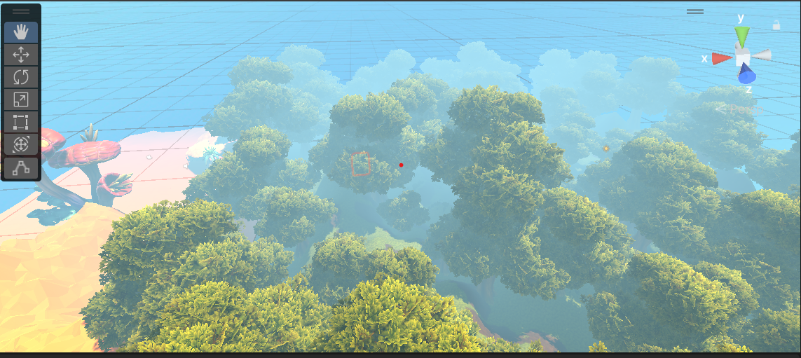

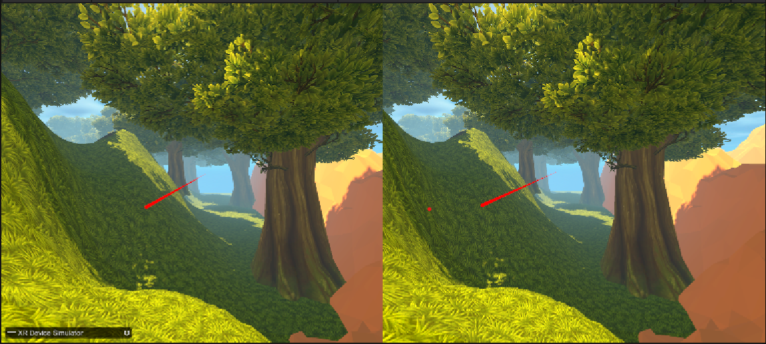

**Tips**

* **Start simple:** Begin with basic interactions and gradually make them more complex.
* **Give feedback:** Use visuals, sounds, and vibrations to let the player know what's happening.
* **Optimize performance:** Make sure the game runs smoothly to avoid lag, which can be unpleasant in VR.
* **Add a scoring system:** To make the game more engaging, you can include a way to keep score.